Fire Detection and Alert System Using PIC Microcontroller

# Project Report

## 1. Abstract

Fire hazards present a critical risk to life and property. Traditional fire detection systems are often expensive and bulky, limiting their usage in smaller setups. This project introduces a low-cost, real-time Fire Detection and Alert System using a PIC Microcontroller. By integrating temperature and smoke sensors, a GSM module, and an alarm system, the project provides early fire detection and immediate notifications via buzzer and SMS, ensuring timely preventive measures.

## 2. Objectives

- Detect fire at an early stage using sensors.  
- Provide local alerts via a buzzer.  
- Send remote alerts via SMS using a GSM module.  
- Ensure real-time monitoring with a cost-effective system.

## 3. Introduction

Fires can cause massive destruction, and early warning systems are essential for prevention. However, commercial systems are often unaffordable for homes or small businesses. This system uses affordable components and a PIC16F877A microcontroller to monitor smoke and temperature levels. It alerts users through a buzzer and GSM-based SMS notification, offering a scalable and efficient fire safety solution.

## 4. Components Used

|  |  |
| --- | --- |
| Component | Description |
| PIC Microcontroller | Controls the system logic (e.g., 16F877A) |
| MQ-2 Smoke Sensor | Detects smoke particles in the air |
| LM35 Temperature Sensor | Detects temperature changes |
| GSM Module (SIM800L) | Sends SMS messages |
| Buzzer | Sounds alarm on fire detection |
| Power Supply | Regulated 5V DC |
| Resistors, Capacitors | Supporting circuit components |

## 5. Block Diagram

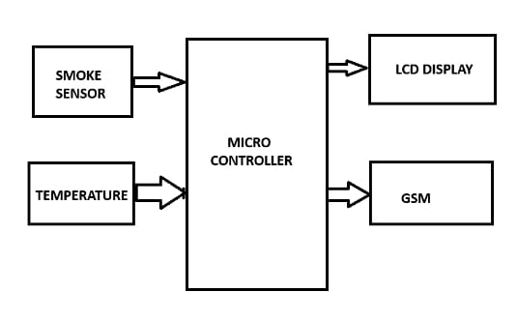

### 6.Conclusion

The Fire Detection and Alert System using a PIC Microcontroller provides a reliable, cost-effective solution for detecting fires and notifying emergency contacts. By using easily available components and leveraging the processing power of a PIC microcontroller, this system ensures early fire detection and rapid alert, preventing significant damage and potentially saving lives. The system is versatile and can be deployed in various environments, making it a practical choice for both residential and commercial applications.